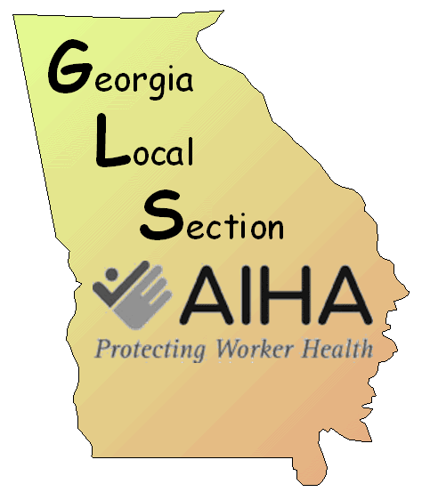
Winter Meeting
GLS Industrial Hygiene Workshop

Georgia Tech Research Institute (GTRI) Conference Center
250 14th Street NW, Atlanta, GA 30318
Auditorium| February 11 – 12, 2015

Wednesday, February 11, 2015

7:30 AM – 8:00 A M | ARRIVAL, REGISTRATION AND BREAKFAST
8:00 AM – 8:15 A M | Opening.  Steven Jahn, Chair, Workshop Organizing  Stephen Ndiritu, President, AIHA-GLS
8:15 AM – 10:15 AM | PDC - Bio-Monitoring: Part 1  "The Process of setting a Health-based ACGIH Biological Exposure Index (BEI): The example of Polycyclic Aromatic Hydrocarbons"  Dr. Glenn Talaska, Director, Environmental & Occupational Hygiene Division, University of Cincinnati
10:15 AM – 10: 30 AM BREAK | BREAK
10:30 AM – 11:30 PM | PDC - Bio-Monitoring: Part 2  "The Process of setting a Health-based ACGIH Biological Exposure Index (BEI): The example of Polycyclic Aromatic Hydrocarbons"  Dr. Glenn Talaska, Director, Environmental & Occupational Hygiene Division, University of Cincinnati
11:30 PM – 12:00 PM | Vendor Introductions
12:00 – 1:00 | LUNCH
1:00 PM – 2:00 PM | PDC - Bio-Monitoring: Part 3  "The Process of setting a Health-based ACGIH Biological Exposure Index (BEI): The example of Polycyclic Aromatic Hydrocarbons"  Dr. Glenn Talaska, Director, Environmental & Occupational Hygiene Division, University of Cincinnati
2:00 PM – 3:00 PM | “Shopper Cards: Saving Money, Solving Outbreaks”  Rashida Hassan, MSPH, Assessment Epidemiologist, Centers for Disease Control and Prevention (CDC)
3:00 PM – 3:15 PM | BREAK
3:15 PM – 4: 15 PM | Exposures from Vermiculite Attic Insulation with <1% Asbestos William M. Ewing, CIH, Technical Director, Compass Environmental Inc.
4:15 PM – 4: 30 PM | Conclusion

Thursday, February 12, 2015

 | 7:30 AM – 8:00 A M | ARRIVAL, REGISTRATION AND BREAKFAST
 | 8:00 AM – 8:15 A M | Opening.  Stephen Ndiritu, President, AIHA-GLS
 | 8:15 AM – 8:45 AM | Exposure Science Promotion and Workshop Introduction  Steven Jahn, CIH, Jahn Industrial Hygiene  Aiken, South Carolina
 | 8:45 AM – 9:45 AM | Mercury Emissions Management Investigation  Alexander Brown, Industrial Hygienist, Savannah River Remediation  Savannah River Site, Aiken South Carolina
 | 9:45 AM – 10:00 AM | Vendor Introductions
 | 10:00 AM – 10: 15 AM | BREAK
 | 10:15 AM – 11:15 AM | Weaponry Change and Impulse Noise Exposure Impacts  Steven Stamper, Industrial Hygienist, Centerra-SRS  Savannah River Site, Aiken South Carolina
 | 11:15 AM – 12:15 PM | Applied Exposure Assessment Cycle (Part 1: Evaluations) at 3M.  Sophia Sushailo, 3M  Atlanta, Georgia
 | 12:15 PM – 1:15 PM | LUNCH
 | 1:15 PM – 2:15 PM | Applied Exposure Assessment Cycle (Part 2: Control) at 3M.  Sophia Sushailo, 3M  Atlanta, Georgia
 | 2:15 PM – 2:30 PM | BREAK
 | 2:30 PM – 3:30 PM | Applications of Microanalysis to Industrial Hygiene  Randy Boltin, Senior Research Scientist, MVA Scientific Consultants  Duluth, Georgia
 | 3:30 PM – 4:30 PM | Update on the 2014 Ebola Outbreak: An Unprecedented Public Health Event  Dr. Omer Pasi, Medical Epidemiologist, Centers for Disease Control & Prevention (CDC)  Atlanta, Georgia
 | 4:30 PM | CLOSING  Steven Jahn, Chair, Workshop Organizing  Stephen Ndiritu, President, AIHA-GLS

